

Mathematics Policy
Numeracy
Mathematics

Head Teacher | Parent Council Chair | Pupil Council Chair
Published: 28th September 2015

Revision No. | Details of Change | Date
1 | Draft policy consultation | May 2015
2 | Final Publication | September 2015

Article 29 (goals of education)
Education must develop every child’s personality, talents and abilities to the full. It must encourage the child’s respect for human rights, as well as respect for their parents, their own and other cultures, and the environment.

Contents

Rationale | 4
Aims and Objectives | 4
Building the Mathematics and Numeracy Curriculum | 5
A Framework for Numeracy/Mathematics Learning and Teaching
The Life and Ethos of the School | 6
The Curriculum | 7
Interdisciplinary Learning (IDL) | 10
Opportunities for Personal Achievement | 12
Equality Statement | 13
Appendix 1 – Scottish Heinemann Maths | 14
Appendix 2 – Numicon | 15
Appendix 3 – BIG Maths! CLIC Lesson example | 16
Appendix 4 - IDL Planner | 17
Appendix 5 – Mathematics & Numeracy Planners | 18
Appendix 6 – Pupil Profile | 19
Rationale
Mathematics is important in our everyday life, allowing us to make sense of the world around us and to manage our lives. Using mathematics enables us to model real-life situations and make connections and informed predictions. It equips us with the skills we need to interpret and analyse information, simplify and solve problems, assess risk and make informed decisions.

Mathematics plays an important role in areas such as science or technologies, and is vital to research and development in fields such as engineering, computing science, medicine and finance. Learning mathematics gives children and young people access to the wider curriculum and the opportunity to pursue further studies and interests.

To face the challenges of the 21st century, each young person needs to have confidence in using mathematical skills, and Scotland needs both specialist mathematicians and a highly numerate population.

All teachers have responsibility for promoting the development of numeracy. With an increased emphasis upon numeracy for all young people, teachers will need to plan to revisit and consolidate numeracy skills throughout schooling.
Building the Curriculum 1

Aims and Objectives

- Improvements in performance
  - Improved standards of attainment over time
  - Improved overall quality of learners’ achievement
  - Increased impact of higher mathematical standards across the curriculum

- Learners’ experiences
  - The extent to which learners are motivated and actively involved in their own mathematical learning and development

- The Curriculum
  - The continuing development/improvement of the curriculum from this current policy
  - Developing pedagogy, programmes and courses
  - Developing/improving transitions between stages (including approaches to and provision for meeting the emotional, physical and social needs of children and young people)

- Meeting learning needs
  - Improved tasks, activities and resources
  - Identification of learning needs with specific learning targets created
  - The roles of teachers and specialist staff to best support pupils

- Improvements through self-evaluation
  - Continued commitment to self-evaluation to best improve numeracy and mathematics involving all stakeholders.
Building the Mathematics and Numeracy Curriculum
BREADTH, DEPTH & PROGRESSION
Experiences and outcomes provide the basis for both lateral (broadening) and vertical (more challenging) progression; they offer opportunities for teachers to plan for development, consolidation and challenge at the secure stage within each level.
At all stages, children will be offered a range of contexts through which they will experience and develop mathematical skills. Designated core materials will be used to promote continuity and progression in the development of skills in number, money, measurement, shape, position, movement and information handling. The rich and motivating resources within themes, topics and real life situations will enable children to practice applying these skills within new and unfamiliar contexts and form the basis for assessing achievement within and across outcomes.
CHALLENGE & ENJOYMENT:
Experiences and outcomes are designed to open up opportunities for active, challenging and enjoyable learning; repeated low level activities such as worksheets or copying from whiteboard are unlikely to provide effective tools in learning. The planned development of mathematical links across the curriculum through interdisciplinary studies will give pupils the opportunity to develop and apply their Mathematical/Numeracy skills in enjoyable and motivating contexts.
Effective use of ICT, active learning, planned purposeful play and critical skills challenges which encourage collaborative learning will have a high profile throughout all stages of the school, thus providing rich and exciting learning environments.
COHERENCE & RELEVANCE:
Numeracy and Mathematical activities permeate all areas of the curriculum: teachers help children to see the links between different aspects of their learning within and across all curriculum areas and interdisciplinary studies.
The content of the curriculum will be relevant to the children’s experience, learning and interests in and beyond the school environment. Teachers engage with learners to make explicit the relevance and to ensure the outcomes and success criteria language is age appropriate and easily understood.
PERSONALISATION & CHOICE
Teachers will build personalisation and choice into the children’s numeracy and mathematical development making full use of personal learning planning to engage with children to record achievable targets. They will provide choice of activities and resources as well as space to pursue aspects of their own learning at an independent level.
A Framework for Numeracy/Mathematics Learning and Teaching

The Life and Ethos of the school
The starting point for learning is a positive ethos and climate of respect and trust based upon shared values across the school community, including parents. All members of staff should:

- Contribute through open, positive, supportive relationships where children and young people will feel that they are listened to;
- Promote a climate in which children and young people feel safe and secure;
- Model behaviour that promotes effective learning and wellbeing within the school community;
- Be sensitive and responsive to each young person's wellbeing.

Children and young people should be encouraged to contribute to the life and work of the school and, from the earliest stages, to exercise their responsibilities as members of a community. This includes opportunities to participate responsibly in decision-making, to contribute as leaders and role models, offer support and service to others and play an active part in putting the values of the school community into practice.

Home/School link.
Parents are valued contributors and as such they are kept fully informed of the strategies the school uses to teach Numeracy and Mathematics. Opinions are sought through newsletters, information leaflets and open afternoons; they are actively encouraged to support their child.
Parents are invited to attend curricular evenings and pupil progress meetings twice yearly. Any parent who is concerned about their child’s numeracy/mathematical progress is encouraged to contact the school.

Parents of pupils who are experiencing difficulties are invited to attend additional meetings to discuss further strategies to support the teaching of numeracy and mathematics.

Numeracy and Mathematics homework is critical in reinforcing concepts taught in the classroom. We aim to have two numeracy and mathematical tasks for our pupils, one that is a practical, game-based, problem solving task and another that is independent of adult assistance (www.educationcity.com).

The Curriculum
Number, money and measurement is at the heart of all learning and will take place daily throughout the whole curriculum. A specific lesson on number, money and measurement will take place regularly and provide the opportunity for the development of specific skills and assessment.

E= Early (Nur-P1), 1st Level (P1-4), 2nd Level (P4-7), 3rd Level (P7-Academy)

 |  | E | 1st | 2nd | 3rd
Number, Money and Measurement | Estimation and Rounding
Number, Money and Measurement | Number and number processes  - Addition  - Subtraction  - Multiplication  - Division  - Negative Numbers
Number, Money and Measurement | Multiples, factors and primes
Number, Money and Measurement | Powers and roots
Number, Money and Measurement | Fractions, decimal fractions and percentages  - Ratio  - proportion
Number, Money and Measurement | Money
Number, Money and Measurement | Time
Number, Money and Measurement | Measurement
Number, Money and Measurement | Mathematics – Its impact on the world, past, present and future
Number, Money and Measurement | Patterns and relationships
Number, Money and Measurement | Expressions and Equations
Shape, Position and Movement | Properties of 2D/3D shapes and objects
Shape, Position and Movement | Angle, Symmetry and transformation
Information Handling | Data and Analysis
Information Handling | Ideas of chance and uncertainty

All children will be given the opportunity to build upon previously learned skills thus encouraging continuity and progression. They will self/peer-evaluate their own performance considering the attributes and qualities of a confident individual. Children will be given the opportunity to work in pairs, trios, and groups for a variety of purposes.

For more detail on the breakdown of expectations at each level please refer to Education Scotland; (http://www.educationscotland.gov.uk/Images/numeracy_mathematics_experiences_outcomes_tcm4-539878.pdf).

Teaching Methodologies

The experiences and outcomes encourage learning and teaching approaches that challenge and stimulate children and young people and promote their enjoyment of mathematics. To achieve this teachers will use a skilful mix of approaches, including:

- planned active learning which provides opportunities to observe, explore, investigate, experiment, play, discuss and reflect
- modelling and scaffolding the development of mathematical thinking skills
- learning collaboratively and independently
- opportunities for discussion, communication and explanation of thinking
- developing mental agility
- using relevant contexts and experiences, familiar to young people
- making links across the curriculum to show how mathematical concepts are applied in a wide range of contexts, such as those provided by science and social studies
- using technology in appropriate and effective ways
- building on the principles of Assessment is for Learning, ensuring that young people understand the purpose and relevance of what they are learning
- developing problem-solving capabilities and critical thinking skills

Our teachers have selected a number of resources that help support and reinforce the learning targets.

Scottish Heinemann Maths (SHM)
This maths scheme is widely used across Scotland due to its specific reference to Curriculum for Excellence Experiences and Outcomes, high quality planning support and guidance, active learning pedagogy and fun, colourful, non-threatening workbooks/textbooks (See Appendix 1).

The scheme does provide an excellent framework for delievering mathematics but this is supplemented with a range of other resources to ensure the pupils receive a broad range of learning experiences that cater to the wide variety of learning styles.

Foveran School has invested in the collaborative problem solving resources from Heinemann. This allows the pupils to apply their mathematical problem-solving skills in contexts that are topical, relevant and meaningful. Our pupils will develop the key skills required to tackle and solve mathematical problems;
- reading and making sense of a problem
- recognising key words, relevant information and redundant information
- finding parts of a problem that can be tackled
- recognising the mathematics which can be used to help solve a problem
- deciding which number operation to perform and in what order
- presenting information and results in a clear and organised way
- checking whether answers make sense

Numicon
With problem-solving, reasoning and conversation, it provides an excellent physical representation for our more visual/kinaesthetic learners (See appendix 2). An excellent resources for our mathematicians that assist by:
- Developing fluency by using a practical base to develop conceptual understanding and fluent recall.
- Helping children to reason mathematically through the use of concrete objects
and spoken language to explain and justify.
- Developing our pupils into confident problem-solvers.

BIG Maths
Big Maths is an excellent resource for improving our mental arithmetic/agility by using CLIC (Counting, Learn Its, It’s Nothing New and Calculation). It makes new learning easy and obvious to children by cashing in on the timeless natural laws of Maths.

‘Big Maths Beat That’ Challenges consist of the CLIC Challenges and Learn Its Challenges, which collectively provide a set of comprehensive questions that assess a child’s ability in core maths. ‘Big Maths Beat That’ has been specifically designed as the assessment element of Big Maths and allows a teacher to measure the progress of each child on a weekly basis.

The CLIC Challenges (see appendix 3) are aligned to each term of a child’s journey through Primary School, assessing their knowledge of core maths skills and their position on that journey. This allows teachers and school leaders to keep a constant ‘progress check’ as the weeks go by… all linked into Curriculum for Excellence age expectations!

The Learn Its Challenges assess those essential facts that, once secure, will allow a child to continue their journey, tackling increasingly complex questions more logically and successfully. Teachers must ensure that the child can recall their Learn Its instantly before attempting the next challenge.

’Big Maths Beat That’ Challenges inform teachers of each child’s ability, which therefore accurately identifies the spread of ability across a class and informs planning and next steps.

Education City
Education City is an online resource full of exciting stage-appropriate mathematics to assist and complement classroom teaching.

- Activities are mapped to national learning experiences and outcomes
- An exciting way to learn Level 1 and Level 2 mathematics with friendly characters and fun, reward-based activities
- Improve attainment by using mathematics activities and learn screens to practise mathematics skills in the classroom and for formative assessment
- Use Tests to track improvements in attainment
- Use Topic Tools for introducing new mathematics topics to the class
- Competitive mental maths game, Play-Live Maths, is perfect for improving mental mathematics skills

Interdisciplinary Learning (IDL)
Effective interdisciplinary learning:
- can take the form of individual one-off projects or longer courses of study
- is planned around clear purposes
- is based upon experiences and outcomes drawn from different curriculum areas or subjects within them
- ensures progression in skills and in knowledge and understanding
- can provide opportunities for mixed stage learning which is interest based

The Foveran School curriculum includes space for learning beyond subject boundaries, so that children can make connections between different areas of learning. Interdisciplinary studies, based upon groupings of experiences and outcomes from within and across curriculum areas, can provide relevant, challenging and enjoyable learning experiences and stimulating contexts to meet the varied needs of children and young people.

Our termly forward planning starts with our Interdisciplinary Topic Planner (See Appendix 4). This will concentrate on approximately 2/3 areas of the curriculum, usually literacy and English, Numeracy and Mathematics, a social subject/science and one other. This gives the opportunity for rich, contextualised learning. Our planners then go into more depth and detail for each of our curricular areas.

Mathematics contributes significantly to the teaching of English in our school by actively promoting the skills of reading, writing, speaking and listening. For example, we encourage children to read and interpret problems in order to identify the mathematics involved. The children explain and present their work to others during plenary sessions. Younger children enjoy stories and rhyme that rely on counting and sequencing. Older children encounter mathematical vocabulary, graphs and charts when using non-fiction texts.

In science lessons, children are able to use and apply their data handling skills when creating tables and graphs of scientific measurements. Whole class discussion of data also highlights the importance of clear recording of information. Children are also able to use a wide range of measuring devices in a real-life context. Children are required to read the scales on Newton meters, measuring cylinders, weighing scales and a variety of other instruments.

Children use and apply mathematics in a variety of ways when solving problems using ICT. Younger children use ICT to communicate results with appropriate mathematical symbols. Older children use it to produce graphs and tables when explaining their results or when creating repeating patterns, such as tessellations. When working on control, children use standard and non-standard measures for distance and angle. They use simulations to identify patterns and relationships.

For Health and Wellbeing, our Numeracy and Mathematics policy encourages independent study and helps them to become increasingly responsible for their own learning. The planned activities that children do within the classroom encourage them to work together and respect each other’s views. We present older children with real-life situations in their work on the spending of money.

The teaching of mathematics supports the social development of our children through the way we expect them to work with each other in lessons. We group children so that they work together, and we give them the chance to discuss their ideas and results. The study of famous mathematicians around the world contributes to the cultural development of our children.

For subject experiences and outcomes not sufficiently covered (breadth, depth) by IDL learning and where specific teaching is required, our numeracy and mathematics planners (see appendix 5) provide specific direction on areas needing to be addressed and any resources that would assist the teaching.

Opportunities for Personal Achievement
Personal achievement provides children and young people with a sense of satisfaction and helps to build motivation, resilience and confidence. Foveran School offers opportunities for recognising achievement through assemblies, Personal Profiles, displays and one-to-one attention given to individuals, teasing out the intricate details of their achievements and the journey they went through to get it.

In maths we participate in the two mathematical based achievement awards;
- University Maths Challenge (primary)
- World Maths Day

We aim to increase opportunities for working closely with local services, business and voluntary organisations to help our pupils’ access information and further opportunities.

With support our pupils evaluate themselves in an ongoing termly cycle using our Curriculum for Excellence Experiences and Outcomes. From this reflective data pupils then create a ‘Personal Learning Plan (PLP)’ that is specific to their needs. Our main outcome is to create reflective children with the skills and knowledge that can be used for personal development. Our senior pupils are paired with an infant/middle stage pupil that they assist in evaluating themselves, creating a plan and undertaking the plan. The pupils will become accustomed to evidencing their progress and recording it using ‘Glow – OneNote’ (See Appendix 6).

We enjoy teaching mathematics to all children, whatever their ability. It is part of the school curriculum policy to provide a broad and balanced education to all children. We provide learning opportunities that are matched to the needs of children with learning difficulties. Work in mathematics takes into account the targets set for individual children in their Individual Education Plans (IEPs) or their Group Education Plans (GEPs).

Assessment
Assessment must inform future learning. There is no point assessing at the end of a unit of work only to discover that the learners haven’t grasped the concept being covered. It must be a continual process to that immediate action can be taken if necessary.
For assessment of learner’s knowledge teachers will use a range of summative material, e.g. Friday tests, feedback through discussion, classwork, National Assessments, INCAS/PIPS baseline assessment, etc.
Formative assessments in class should be continual. This may include classwork, fist to five, coloured marking trays, thumbs up/down, traffic lights, etc.

Assessment data is used by the Head Teacher to track/monitor progress and teachers to plan further learning and teaching in numeracy and mathematics.

Equality Statement
“The Foveran School staff are committed to providing the full range of opportunities for all pupils, regardless of gender, disability, ethnicity, social, cultural or religious background. All pupils have access to the curriculum, and the right to a learning environment, which dispels ignorance, prejudice or stereotyping.”
Ref: (UNICEF, CRC, Article 28)
Appendix 1
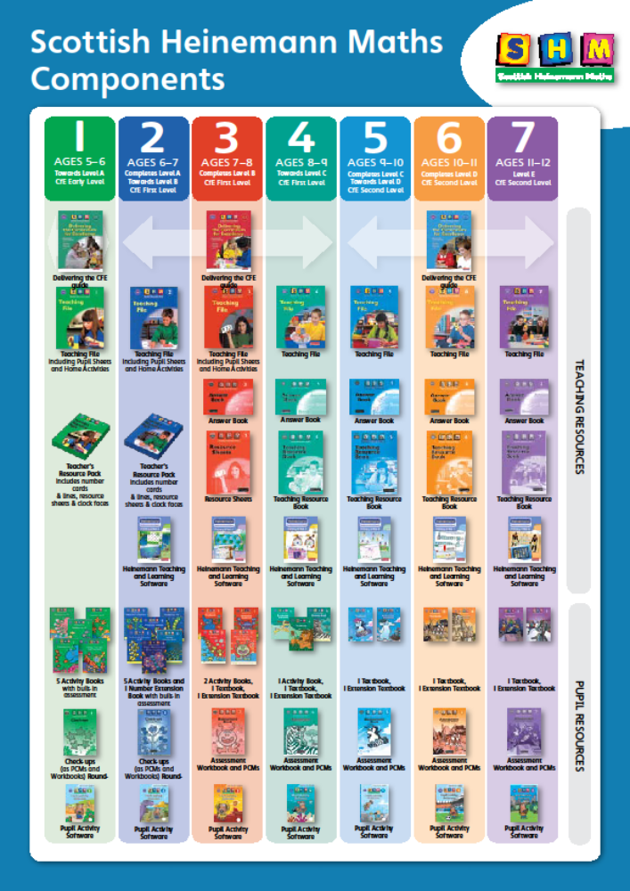
Appendix 2 –Numicon

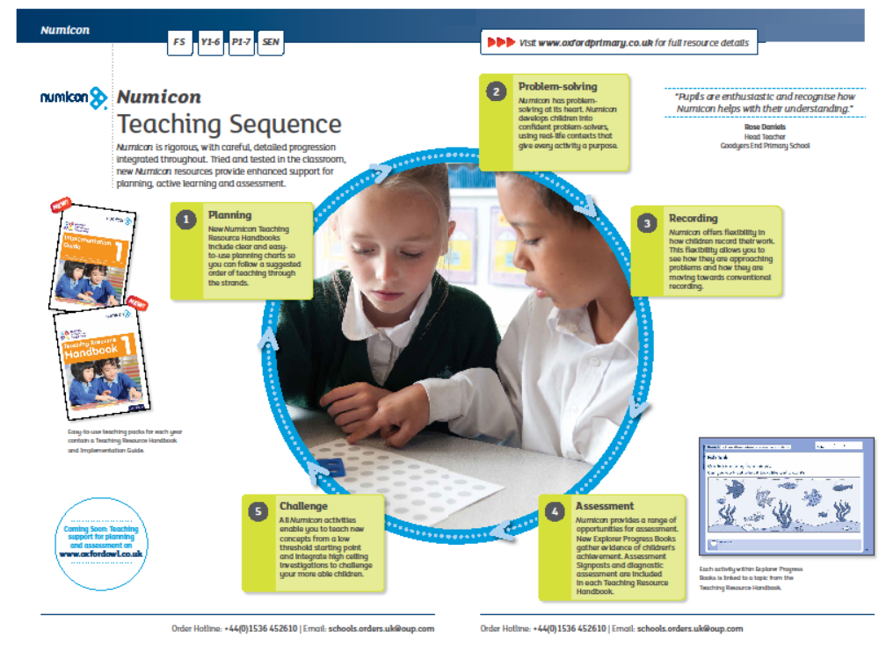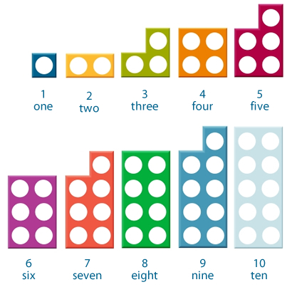
Appendix 3 – BIG Maths! (CLIC)
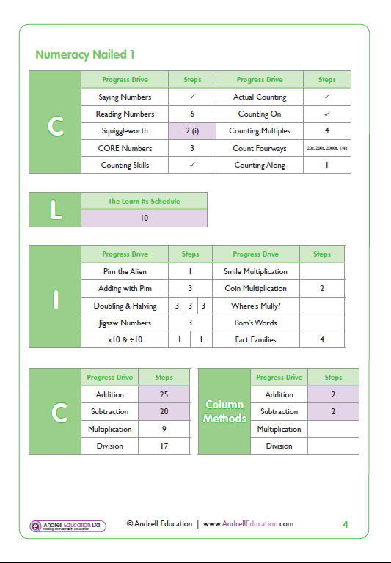
Appendix 4 - Interdisciplinary Topic Planner

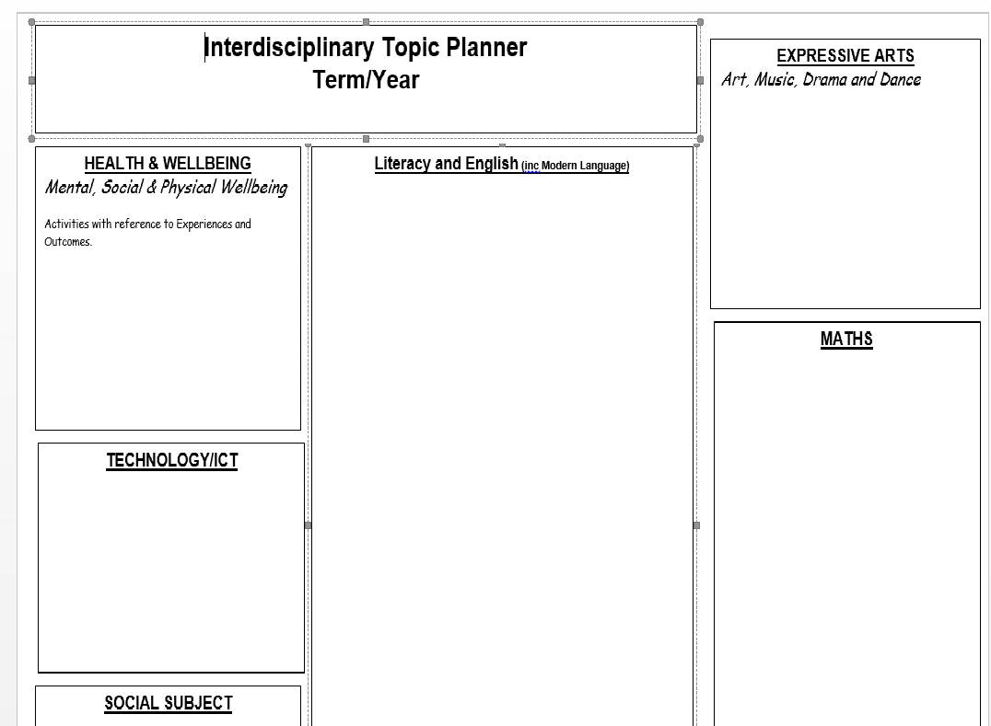

Appendix 5 -
Numeracy and Mathematics Planners

Negative Numbers
I can show my understanding of how the number line extends to include numbers less than zero and have investigated how these numbers occur and are used. MNU2-04a
Second Developing | Notes
I can read and record from a thermometer.
I can place negative numbers in sequence on a number line and be able to identify numbers before, after, in between.
Second Consolidating | Notes
I can find numbers on a number line that are more, less, 2 more, 2 less…
In the context of temperature, I can +/- using the number line.
Second Secure | Notes
In the context of temperature, I can +/- mentally, e.g. -5 degrees then the temperature increases by 3 degrees. What temperature is it now?
I can use negative numbers in 4 quadrant coordinates.

Fractions, decimals and Percentages – First Level

Developing activities | Consolidating activities | Secure activities
Oral Discussion  Practical Work | Education City First ** Ready, Steady, Bake! 1 and 3 | Education City First ** Captain Cod 2
SHM - Developing | SHM - Consolidating | SHM - Secure
SHM 2 Money & Fractions p 12  SHM 2 Money and Fractions p13 | SHM 2 Money and Fractions p 14, 15  SHM 3 Textbook p 67, 68  SHM 3 Workbook p 35  SHM 3 Textbook p 47
Websites
www.ictgames.com

Appendix 6

Individual Pupil Profile



