Foveran School

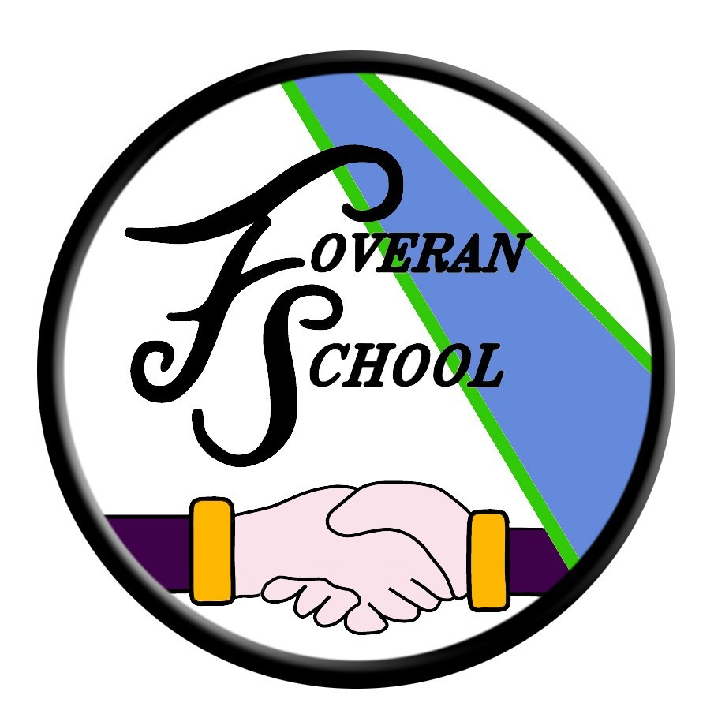

Child Protection Policy

Child Protection

In the context of these guidelines, the term “Child Abuse” incorporates suspected as well as actual abuse of children. Provided there are reasonable grounds for suspicion each instance of actual or suspected Child Abuse must be reacted to and followed up as indicated in these guidelines.

These guidelines take into consideration the articles in the United Nations Convention on the Right of the Child that state that protection is a right:

Article 3

- In all actions concerning children, whether undertaken by public or private social welfare institutions, courts of law, administrative authorities or legislative bodies, the best interests of the child shall be a primary consideration.
- States Parties undertake to ensure the child such protection and care as is necessary for his or her well-being, taking into account the rights and duties of his or her parents, legal guardians, or other individuals legally responsible for him or her, and, to this end, shall take all appropriate legislative and administrative measures.
- States Parties shall ensure that the institutions, services and facilities responsible for the care or protection of children shall conform to the standards established by competent authorities, particularly in the areas of safety, health, in the number and suitability of their staff, as well as competent supervision.

Article 19

- States Parties shall take all appropriate legislative, administrative, social and educational measures to protect the child from all forms of physical or mental violence, injury or abuse, neglect or negligent treatment, maltreatment or exploitation, including sexual abuse, while in the care of parent(s), legal guardian(s) or any other person who has the care of the child.
- Such protective measures should, as appropriate, include effective procedures for the establishment of social programmes to provide necessary support for the child and for those who have the care of the child, as well as for other forms of prevention and for identification, reporting, referral, investigation, treatment and follow-up of instances of child maltreatment described heretofore, and, as appropriate, for judicial involvement.

The North East of Scotland Protection Guidelines for Aberdeenshire – NESCPC Child Protection Guidelines identifies five categories of child abuse which must be recorded and acted upon:

- Physical Injury

- Non-Organic Failure To Thrive

- Emotional Abuse/Emotional Neglect

- Sexual Abuse

- Physical Neglect

Any member of staff who has abuse reported to them should, without delay, contact the Head Teacher, who is the designated member of staff dealing with all such instances. If the Head Teacher is not immediately available, the other designated member of staff should be immediately alerted.

Where the Head Teacher or in the Head Teacher’s absence other designated members of staff judge that there is evidence of abuse or potential danger to a child then contact will be made with the Divisional Social Work Department in accordance with the NESCPC Child Protection Guidelines.

Full copies of these guidelines are located in the flowchart within this policy. This policy can be found:

- SCHOOL WEBSITE
- STAFF POLICY FOLDER
- HEADTEACHER’S OFFICE

Annual Actions

Each year Foveran School will publish information through the parent handbook making parents aware of the school’s Child Protection Guidelines. In particular this will make parents aware that in situations where there is a possibility that a child could be at risk of abuse or neglect, the school is required to refer the child to Social Work, the Police or the Reporter and that under these circumstances, the parents would not normally be consulted first.

Child Protection Statement

Aberdeenshire Council Education and Children’s Services are committed to ensuring the safety and wellbeing of all children and young people.

“It’s everyone’s job to make sure I’m alright.” Scottish Executive 2002 highlights the importance of protecting all children and young people, therefore we are required to report if we think any young child/ young person has come to harm or is at risk of harm as a consequence of possible abuse.

Education and Children’s Services have designated Officer’s appointed to be responsible for Child Protection matters and specially trained for the task.

Should you wish to talk further about Child Protection and the safety of children please free to contact the Head Teacher.

When there is the possibility that a child/young person could be at risk of abuse or neglect then a referral will be made to Social Work, the Police or the Reporter.

FOVERAN SCHOOL

CHILD PROTECTION POLICY

All children have a right not to be abused and to be protected from abuse and neglect, therefore child protection is the responsibility of everyone. ‘It’s everyone’s job to make sure I’m alright’ (Scottish Executive, Nov 2002) underlines the need for us all to take responsibility in order to protect children.

At Foveran School we are committed to creating an environment in which children are safe from abuse and in which any suspicion of abuse is responded to promptly and appropriately. The wellbeing of children in our care takes precedence over any other consideration. It is the clear responsibility of all those involved in our school to adopt good practice throughout their work.

In order to achieve this, we will:

- Seek to work in partnership with parents, carers, other agencies and Aberdeenshire Council to promote good practice in the area of child protection.
- Update any changes in child protection policy and practice under the guidance from the designated person in the school
- Endeavour to ensure that all staff have access to appropriate child protection training, supervision and support in order to implement this policy effectively and with the minimum of stress.

****** The detailed arrangements, systems and procedures for ensuring that the above policy statements are fully implemented are contained in the” National Guidance for Child Protection in Scotland”. It was agreed at Aberdeenshire Child and Family Protection Committee on 27 November 2014 that -

In Aberdeenshire, from 1 December 2014 – all Child Protection reference will be to
The ‘National Guidance for Child Protection in Scotland; 2014’

Link -
National Guidance for Child Protection in Scotland

Child abuse is a criminal offence. All staff working in our school have an ethical duty to report any reasonable concern that a child may be being abused.

The role of members of staff is to inform the designated person of any instance, which suggests that abuse is taking place. It is not the role of the member of staff to wait for proof, investigate or gather evidence of abuse.

When a child tells an adult about possible abuse, his or her statements should not be dismissed or ignored. The adult should attend carefully to what the child wants to communicate, taking account of the child’s age and stage of development, and allow the child to say what he or she wants to say without being drawn into detailed questioning.

Our school will always seek to work with families in a clear, positive and open way, bearing in mind always that the welfare of the children is paramount.

In our school the designated person is: Mr Jamie Ferguson HT
In their absence their deputy is: Mrs Amanda Russell

COPIES OF CHILD PROTECTION POLICY GUIDELINES are available from the designated person

REMEMBER:

Any concerns about the well-being of a child need to be shared.

No matter how good we are at evaluating and assessing matters to do with children in our classes, when it comes to the child’s welfare we cannot evaluate and assess potential danger, risk, damage, as we only know a tiny part of the whole picture. We must share our concerns with the designated person.

Staff should use the attached flow-chart if:
- A child discloses abuse, or
- A member of staff suspects a child may have been abused, or
- A third party expresses concern
- A staff member witnesses an abusive situation involving another staff member

The member of staff must: RECORD and REPORT

R Respond without showing any signs of disquiet, anxiety or shock

E Enquire casually about how an injury was sustained or why a child appears upset

C Confidentiality must not be promised to children or adults in this situation

O Observe carefully the demeanour or behaviour of the child

R Record in detail what has been seen and heard (GC! FORM ATTACHED)

D Do not interrogate or enter into detailed investigations: rather encourage
the child to say what he/she wants until enough information is gained to decide whether or not a referral is appropriate

Then REPORT to the designated person without delay.

Members of staff must not

- Investigate suspected/alleged abuse themselves
- Evaluate the grounds for concern
- Seek or wait for proof
- Discuss the matter with anyone other than head teacher/senior staff.

Further information can be found in the
‘National Guidance for Child Protection in Scotland; 2014’which can be obtained from the office.

Foveran School Child Protection Action Flowchart
Member of staff is concerned that a pupil may have been subject to some form of abuse. This may be because of observation or due to disclosure a pupil has made to the member of staff.

Member of staff will complete a GC1 Concern Form and hand immediately to Mr Ferguson.

If Mr Ferguson is unavailable and concern considered urgent, member of staff to contact neighbouring Headteacher.

Headteacher will decide as to the next course of action. This may be to monitor the situation, to contact parents or to contact social work.

Social work may investigate the matter. If social work concludes there is nothing untoward, case will be closed. If social work wishes to pursue, they will action accordingly.

Every step and every action will be recorded, and information will be stored confidentially.

Whilst it is understood that some parents do often have queries regarding the above steps, we have a duty of care to every child in our care, and it is absolutely essential that we follow procedure in order to ensure the safety of our young people.

I am very happy to discuss this matter with any members of the wider school community – feel free to contact me at the school.

Jamie Ferguson
EDUCATION PROCEDURES FOR THE MANAGEMENT OF CASES OF CHILD ABUSE OR CHILD PROTECTION COMING TO THE NOTICE OF EDUCATION STAFF

- A designated member of staff is responsible for co-ordinating action on child abuse within the establishment. Referrals should normally be through this designated person but every employee has the responsibility to make a direct referral if this is necessary.

- Any member of staff suspecting or identifying child abuse, should, without delay, contact the designated member of staff. If contacting the designated person implies delay beyond the end of the school day or community education session, an assessment should be made of the child’s safety and, if necessary, a direct referral should be made.

- Where the designated member of staff judges that there is evidence of abuse or potential danger to a child then he/she must ensure that Social Work is contacted (this to include discussion as to how parents are engaged). It is important that all staff understand that investigation only needs to establish evidence of the need to investigate abuse. A full inquiry by Education staff must be avoided because collection of evidence is a specialist Police/Social Work role. Inappropriate inquiries may prevent successful prosecution.

- If it is considered that the child required immediate medical attention, contact Ellon Health Centre, Health Visitor, School Doctor or Royal Aberdeen Children’s Hospital as appropriate. If there is a view that the child may risk further abuse if returned home, the Police and Social Work must be informed as soon as possible and preferably well before the end of the day.

- When the designated member of staff considers that further investigation is required before suspicions can be confirmed or rejected, he/she can contact social work and any other agency who may be able to assist in any such inquiries or who may have information about the child or family. In particular the School Health Visitor and in Aberdeen the Home – School Liaison Officer, but also including the child’s General Practitioner and, if actively involved in the case, Educational Psychologist.

The designated officer may also check the Child Protection Register.

- A Head of Establishment may, of course, at any time draw to the attention of the Reporter (Authority Reporter – Aberdeenshire – 01224-565179) to the Children’s Panel the circumstances of a child who is believed to be in need of compulsory measures of care. Out of hours emergency number 08458400070

- In all cases, incidents should be logged, action taken and recorded in the GC1 Form appended.

- The Educational Psychologist Service has designated responsibility for this area and can be contacted at Craigearn Business Park, Morrison Way, Kintore, Inverurie.
Tel: (01467-634759)

9. It is essential to maintain strict confidentiality in all child protection matters. Breach of confidentiality is a serious disciplinary matter and must be reported immediately to the line manager.

10. The Head of Establishment will:

- Ensure that all appropriate staff, including new staff, on an ongoing basis, are made familiar with the contents of this booklet.
- Ensure there is a quality PSE programme.

11. It is possible that employees are implicated in abuse. Indeed, any adult or child may be an abuser and research shows that some abuse may be perpetrated by women or men, or women and men acting in partnership. Disclosure should not be discounted because of the status or role of the alleged abuser.

The Policy will be revised annually using the following checklist:

Checklist: Evidence

- Is there a named person responsible for Child Protection?

- Is there a copy of the Authority Child Protection Guidelines available for Teachers?

- Is there an annual review of Child Protection requirements?

- Are there arrangements to inform new and temporary staff about authority and establishment policy?

- Are there appropriate curriculum
experiences where children may learn about the value of family life?

- Do children know whom they can talk to about bullying and Child Protection matters?

- The value, benefits and overall approach from the implementation of this policy and procedures will be reviewed annually.

- Any changes will be discussed and communicated to all staff immediately.

- Consultation on this policy as draft will be conducted with staff and the Foveran Parent Council

The Head Teacher at Foveran School welcomes feedback on this document.

Contact:

Foveran School
Main Road
Foveran
Ellon
Aberdeenshire
AB41 6AZ

Tel: 01358 281115
E mail: Jamie.ferguson@aberdeenshire.gov.uk

