Foveran School

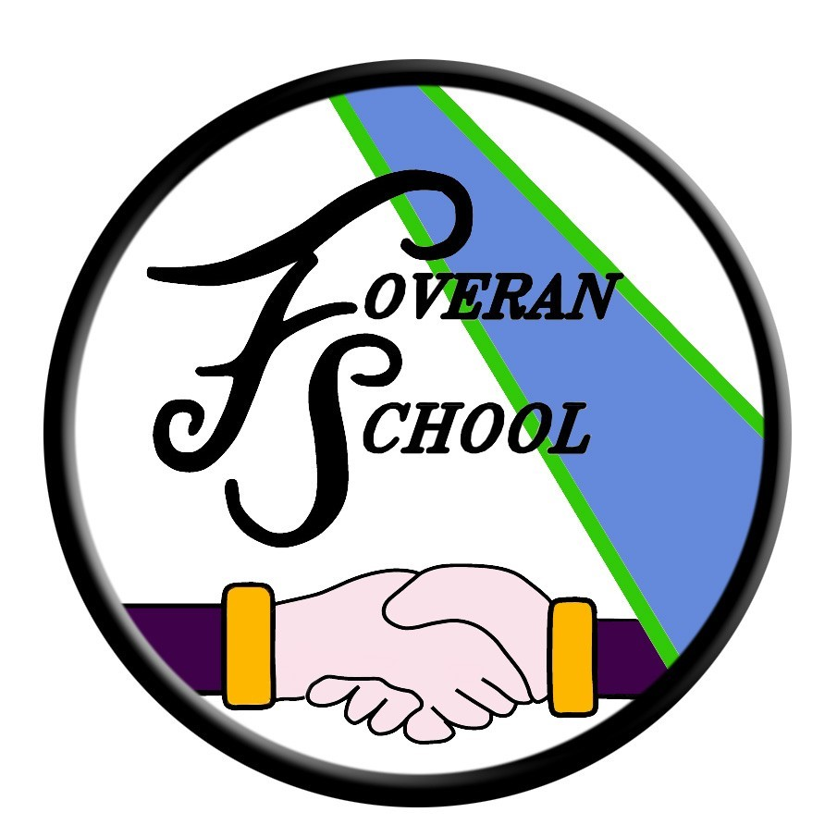

Composite class policy
Draft policy – Aug 2020

Composite Class Policy Guidelines for Parent Information.
Teachers are allocated to a school strictly according to the total pupil roll. It is the responsibility of the head teacher, in consultation with teaching staff, to organise classes accordingly. The maximum straight class size for P4 to P7 is 33 pupils, for P2 and P3, 30 pupils and for P1 25 pupils. It is rare for any school to have numbers of pupils that always result in “straight” classes and is very unlikely in Foveran. When a year group is over these numbers, another class has to be formed. In a smaller school, where pupil numbers in each year group are less, classes are made up of more than one year group. The maximum in a composite class is 25. At the beginning of the year, it is best practice to try and leave 2 spaces available for each year group. This is to accommodate new pupils arriving in zone without having to rearrange classes.
When forming composite classes, head teachers use their professional judgement, bearing in mind the following criteria:
• Cohesive teaching groups
• Working groups (reading and maths)
• Reasonable balance of boys / girls
• Range of age / maturity
• Awareness of relationships which could affect a pupil’s classroom work
• Range of ability
While it might be easy to simply select pupils on date of birth, or alphabetical order, this will not meet the above criteria that are essential to promote the most effective teaching and learning. If we select, for example, eight children by alphabet or date of birth we run the risk of isolating children from a cohesive working group. It also means the teacher could be faced with eight children who are all at different stages of the curriculum and who would have to work as individuals.
Points to note:
• Class sizes and structure are reviewed annually and depend entirely on whole school staffing and pupil numbers.
• We will never isolate children from their year group by forming a composite class with only one child from a particular primary stage.
• Once a composite class is formed it may remain so for more than one year.

Further points to note:
• It must not be assumed that the younger group in a composite class has been “promoted” in some way, or that the older group has been “held back”.
• The class teacher will know exactly where the pupils are with regard to maths and language and will teach them appropriately.
• Any children selected for the younger section of the composite class will not be expected to cover work they are not ready for.
• Any children selected for the older section of the composite class will not be asked to repeat work they have already mastered or topics they have already covered.
• A shared curricular area, such as Religious & Moral Education or Personal & Social Development is planned on a cyclical basis such that work is not repeated, and therefore all children will build on and develop the skills they gained in the previous year. Each class will be taught investigative skills and will develop knowledge and understanding, but the range of skills and level of understanding for each pupil will vary, according to each pupil’s ability.
• There is no such thing as a set curriculum for each year group, and children are not disadvantaged in any way by being taught in a composite class. The smaller class size can be seen as a distinct advantage.
Finally:
• Within one straight class, of up to 33 children, there can be a wide spread of attainment. By P6 and P7 there can be a wide range with some children at early First Level and others at Second Level. Teachers are well used to catering for groups of different abilities - it is at the heart of good teaching. Indeed it could be said that every class is a composite class!
• All pupils are taught according to the Curriculum for Excellence, and will make progress through the levels at their own pace.
• At Foveran School we aim to give every pupil the chance to succeed and achieve the best they can. This means that, wherever possible, pupil levels of attainment will be in line with or above national expectation.
Draft policy August 2020

