Foveran School

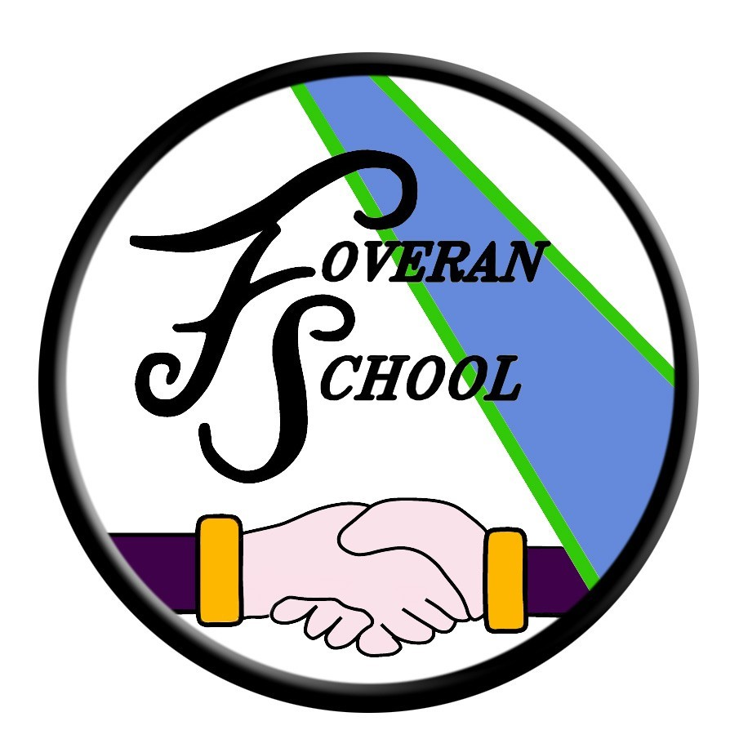

Health and Wellbeing policy

Health & Wellbeing Policy

Aims “Learning in health and wellbeing ensures that children and young people develop the knowledge and understanding, skills, capabilities and attributes which they need for mental, emotional, social and physical wellbeing now and in the future. Learning through health and wellbeing enables children and young people to:

• Make informed decisions in order to improve their mental, emotional, social and physical wellbeing.

• Experience challenge and enjoyment.

• Experience positive aspects of healthy living and activity for themselves.

• Apply their mental, emotional, social and physical skills to pursue a healthy lifestyle.

• Make a successful move to the next stage of education or work.

• Establish a pattern of health and wellbeing which will be sustained into adult life, and which will help to promote the health and wellbeing of the next generation of Scottish children.” Health and Wellbeing Principles and Practice

We aim to deliver a health and wellbeing programme which allows teachers scope to plan for a wide variety of experiences which will enable young people to develop the knowledge, skills and capacities which they need for mental, physical, social and emotional wellbeing now and in the future. We aim to deliver two sessions of physical activity per week.

A variety of activities have been created for Early, First and Second Level based on the Health and Wellbeing outcomes and experiences from Curriculum for Excellence. These have been structured underneath the following organisers:

• Mental, Emotional, Social and Physical Wellbeing

• Planning for Choices and Changes

• Physical Education, Physical Activity and Sport

• Food and Health

• Substance Misuse

• Relationships, Sexual Health and Parenthood

The Head Teacher at Foveran School welcomes feedback on this document.

Contact:

Foveran School
Main Road
Foveran
Ellon
Aberdeenshire
AB41 6AZ

Tel: 01358 281115
E mail: Jamie.ferguson@aberdeenshire.gov.uk

