Foveran School

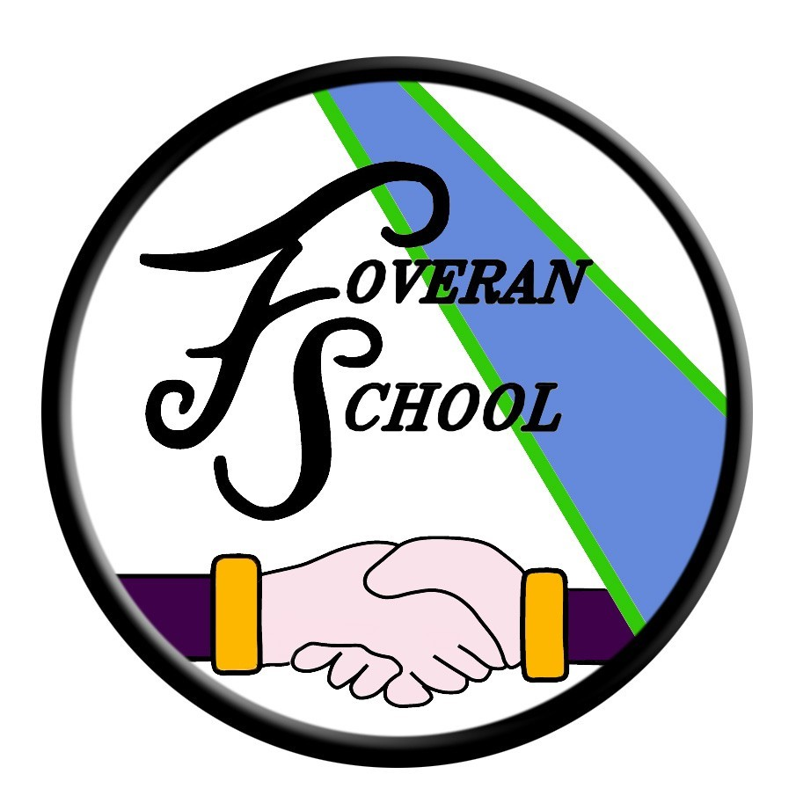

Homework Policy

Homework Policy

The purpose of this policy is to give pupils, staff and parents/ carers guidance on how homework is approached at Foveran School.

We recognise the need for homework to fit suitably with the challenges of modern life and how it should also reflect an understanding of our school community. We place value on the learning that takes place outside of school across a range of situations including; playing outside, attending clubs, building friendships and developing life skills.

The most up to date educational research, including the work of John Hattie, has been used to support critical thinking, debate and evaluation.

Who is Responsible?

Staff- will ensure that the homework given is both relevant and meaningful to the learner.

Parents/ Carers- should support the learner in tasks, and should communicate any difficulties or concerns with the class teacher.

Pupils- should be encouraged to complete the homework to the best of their ability, with a sense of pride.

How will the policy be implemented? According to Professor John Hattie: “Homework that provides another chance to practice something already taught and for which a student has the beginnings of mastery can be effective” (Hattie 2016). With the above in mind, Reading homework and mental maths will be given regularly according to age and stage. Class teachers will also provide suggestions of other open-ended learning activities pupils and families may want to investigate (optional).

Homework could typically include;

• *Structured reading from P1 onwards.

• *Mental maths skills practice

• Reading for enjoyment

• ICT based learning tasks across all areas.

• Talk homework.

• Researching current learning topics

• Life skills challenges

• Whole school challenges

• Family games

The Head Teacher at Foveran School welcomes feedback on this document.

Contact:

Foveran School
Main Road
Foveran
Ellon
Aberdeenshire
AB41 6AZ

Tel: 01358 281115
E mail: Jamie.ferguson@aberdeenshire.gov.uk

