Foveran School

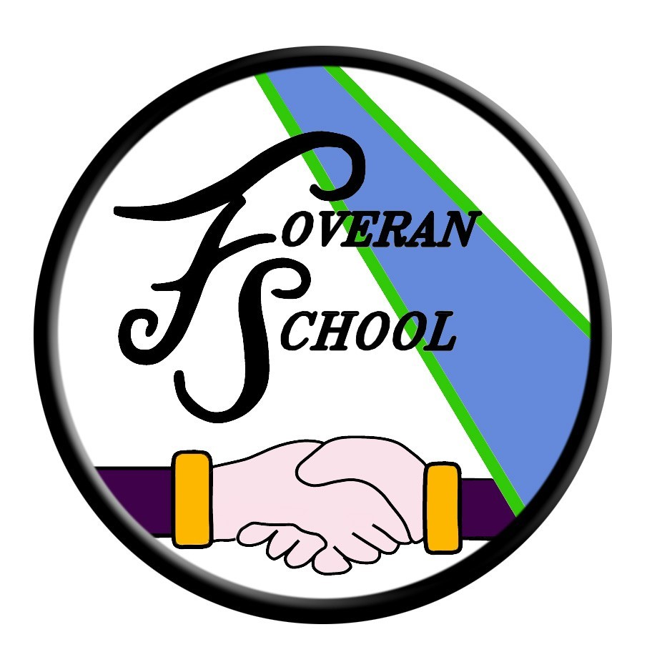

Languages Policy

Rationale
“Language is at the core of thinking. We reflect, communicate and develop our ideas through language. Literacy offers an essential passport to learning, helping children and young people to achieve to the full and be ready for active involvement in society and work.”

Literacy is an over-arching subject that is fundamental to all areas of learning, as it unlocks access to the wider curriculum. Every teacher in each area of the curriculum needs to find opportunities to encourage our pupils to explain their thinking, debate their ideas and read and write at a level which help them to develop their language skills further.
Building the Curriculum 1

Aims and Objectives

- Improvements in performance
  - Improved standards of attainment over time
  - Improved overall quality of learners’ achievement
  - Increased impact of higher literacy standards across the curriculum

- Learners’ experiences
  - The extent to which learners are motivated and actively involved in their own literacy learning and development

- The Curriculum
  - The continuing development/improvement of the curriculum from this current policy
  - Developing pedagogy, programmes and courses
  - Developing/improving transitions between stages (including approaches to and provision for meeting the emotional, physical and social needs of children and young people)

- Meeting learning needs
  - Improved tasks, activities and resources
  - Identification of learning needs with specific learning targets created
  - The roles of teachers and specialist staff to best support pupils

- Improvements through self-evaluation
  - Continued commitment to self-evaluation to best improve literacy and English involving all stakeholders.

Literacy and English Curriculum Area
Talking & Listening
Listening and talking is at the heart of all learning and will take place daily throughout the whole curriculum. A specific lesson on listening and talking will take place regularly and provide the opportunity for the development of specific skills and assessment.

 | P1 | P2 | P3 | P4 | P5 | P6 | P7
Listening Skills
Skills of Social Conventions
Recounting
Description/Explanation
Giving/Responding to Instructions
Classification
Questioning and Enquiry
Negotiation
Persuasion

Reading
In primaries one to three, pupils are taught comprehension and word attack skills using a guided reading approach. All books, both fiction and non fiction, are organised by text banding and have been selected from a wide range. Children do not follow a specific reading scheme but are encouraged to read a wide variety of texts matched specifically to their ability
Guided reading involves:
- Introduction/walkthrough (teacher encourages pupils to predict the content and goes through each page, drawing attention to significant or difficult vocabulary).
- Independent reading (pupils read text aloud at their own pace, monitored by teacher).
- Returning to the text (discussion of the story linked to characters, events, setting, significant vocabulary, authors choice of words).
- Follow up activities (range of active integrated literacy tasks e.g. sequencing, strip books, etc).
Children are taught specific word attack strategies including:
- Visual cues (word shape, pictures)
- Re-reading (context, grammatical clues)
- Visual/Auditory Clues (initial/final letter, phonemes, syllables)
- Sound out all the letters and blend them together.
- Read the sentence again.

Comprehension strategies taught will include:
- Monitoring understanding – skimming and scanning text, make predictions, ask and answer questions, identifying key words which give information.
- Summarising – main events, scan for specific information, evaluate text.
- Recognising story structure – setting, events, and plot.
- Using pictures and word plans – identifying pictures, diagrams, headings, illustrations that make information clear.
- Answering questions – ‘Find it, prove it, and talk about it’.
- Other strategies – use of grammar/word attack/punctuation to self correct, authors’ use of words/phrases/devices.

Children progress from the banded books to novels when they demonstrate good levels of comprehension, fluency and independence. This is most often when children reach the end of the gold level of banded books, usually during primary three, when they will progress onto the skinny novels. At this point the children are encouraged to talk about the text in order to search for meaning and show a clear understanding. Developing fluency shifts from reading aloud to being encouraged to read for longer periods of time either independently or with a partner.

Higher order thinking skills and comprehension strategies taught will include:
- Using active thinking about prior knowledge (metacognition) – what do I already know?
- Using active thinking about words and phrases (metalinguistic) – developing their vocabulary, word building and knowledge of writer’s craft.
- Using active thinking about sensory images (visualisation) – creating images/pictures in the mind, abstract ideas, elaborating/comparing/discussing, mind mapping.
- Using active thinking to draw inferences (metacognition) – using stated and implied messages to find out about characters, settings, main events, etc.
- Using active thinking to find main ideas (metacognition) – using stated and implied messages, reading between the lines.
- Using active thinking to summarise the text (metacognition) – condensing the key message, summarising the essence of meaning, etc.

In order to develop skills in reading and understanding, children will be encouraged to:
- Read, think, question and take notes.
- Discuss, share and question.
- Draw conclusions and clarify understanding.
Word attack strategies are the same for all children from primaries one to seven.

In addition to the teaching of fiction using novels, pupils are provided the opportunities to read a wide range of non-fiction texts. Teachers select appropriate texts to match the children’s ability, books have been sourced to provide challenge, variety and choice and have also taken into account pupil interests. When teaching non-fiction, teachers must provide opportunities for learners to:
- Identify and read sections/topics that are of interest.
- Record their prior knowledge of the topic.
- Make notes as they read to clarify understanding and allow them to share their thoughts with others.
- Use their notes to produce high quality writing.
- Present their knowledge to others.
- Discuss how their knowledge/opinion has been changed/affected.
- Carry out further research on the topic using other sources.
In addition to this children will be encouraged to participate in paired reading activities with a peer, older child or adult and will be given opportunities to read independently for enjoyment.

Writing
Children will experience a weekly taught writing lesson during which they will be explicitly taught using the features of genres as detailed in CFE. The six main genres for writing are instructional/procedural, narrative, explanations, information reports, persuasion and recounts. Pupil targets and success criteria for each genre are shared with pupils and a list of core targets across all genres will be inside the front cover of their taught writing jotter.

Children should be encouraged to make use of their skills in writing across all areas of the curriculum. They should consistently demonstrate the same high standards in writing that they have shown during the taught writing lesson.

Success in writing is dependent on the development of the following skills:
- Accuracy in spelling a range of words.
- Grammatical knowledge and punctuation.
- Understanding of and an ability to write in a variety of forms.
- Ability to appreciate the writer’s craft.
- Neat, legible handwriting.
These must be taught specifically through direct teaching, modelling and discussion of the types of text. Children should be given the opportunity to practice these skills on a daily basis through independent writing contexts. All children will experience a weekly taught grammar and handwriting lesson with opportunities for reinforcement and consolidation.

During writing sessions children will be supported by the class teacher and in some cases a Pupil Support Assistant (PSA) or Support for Learning Teacher. As children’s understanding of the written language progresses, they are encouraged to write independently.

Grammar and handwriting are important technical skills which are developed through specifically taught lessons. We use Nelson Grammar and Handwriting to support the teacher in providing a coherent and progressive course for teaching these technical skills. During writing lessons the children will be expected to demonstrate their ability and understanding of these skills.

At the editing stage children are encouraged to read over their work, check spelling, add detail and make improvements.

Phonics & Spelling
In primaries one to three, spelling and phonics are taught separately. In phonics, children are taught the initial sounds before moving on to phonemes. Sounds and phonemes are taught using a variety of strategies including songs, rhymes and magnetic letters. The Jolly Phonics resource is used at this stage.

Pupils are quickly encouraged to blend their taught sounds together to make words. Using magnetic boards children are encouraged to say, make/break, blend, read and write words using their magnetic letters. At primary two and three the children are encouraged to cover the word before they write it.

Common words form the basis of the spelling programme. Pupils are introduced to the words appropriate at their stage and are encouraged to read and write these words correctly through focused lessons and in their daily writing activities. At primary two and three spelling will also involve words linked to the learned phoneme and activities may include dictation.

In primaries four to seven, spelling and phonics are more combined. Children will receive regular input on specific spelling patterns, rules and strategies and use a variety of activities on a daily basis to reinforce these. The school’s core programme is intended to be a natural progression from the spelling component of the North Lanarkshire Active Literacy programme. Level 1 of the core programme covers the same phonics (along with similar key-words) as the lists of spelling words in Active Literacy. It is hoped, therefore, that the majority of pupils who go through the initial three stages of Active Literacy will arrive in Primary 4 with a spelling age in line with (or above) their chronological age and will be able to embark on the core programme at least midway through Level

Interdisciplinary Learning (IDL)
Effective interdisciplinary learning:
- can take the form of individual one-off projects or longer courses of study
- is planned around clear purposes
- is based upon experiences and outcomes drawn from different curriculum areas or subjects within them
- ensures progression in skills and in knowledge and understanding
- can provide opportunities for mixed stage learning which is interest based

The Foveran School curriculum includes space for learning beyond subject boundaries, so that children can make connections between different areas of learning. Interdisciplinary studies, based upon groupings of experiences and outcomes from within and across curriculum areas, can provide relevant, challenging and enjoyable learning experiences and stimulating contexts to meet the varied needs of children and young people.

Opportunities for Personal Achievement
Personal achievement provides children and young people with a sense of satisfaction and helps to build motivation, resilience and confidence. Foveran School offers opportunities for recognising achievement through assemblies, Personal Profiles, displays and one-to-one attention given to individuals, teasing out the intricate details of their achievements and the journey they went through to get it.
A Framework for Learning and Teaching of Modern Languages (French and Spanish)

Introduction
Foveran School recognise the importance of learning a foreign language and embraces the Principles and Practice as outlined in the Curriculum for Excellence : Modern Languages document.
At Foveran School, French and German is taught to all pupils in our upper stages class. As encouraged by Education Scotland ‘Language Learning in Scotland, A 1+2 Approach’ we teach our infant class basic French to help prepare the pupils for the more formal curricular exposure in the senior class.
At Early and First levels, children will be developing generic skills in their first language. These include taking part in conversations, developing listening, reading and writing skills and knowledge about language. All of these are relevant to learning other languages. Within Modern Languages at these stages teachers will be able to build on children’s natural curiosity for sounds and words, and their strong desire to communicate. Activities will include playing games, singing songs, carrying out simple instructions, and playing with simple poetry and rhyme. In this way they can begin to be enthusiastic, confident language learners from the outset.
Whenever they start their learning of another language, children need to experience success by taking part in practical activities that they can enjoy. Language learning is greatly enhanced where it is linked to or embedded in the wider curriculum so that children and young people can enjoy exploring and using language in meaningful contexts. Very importantly, teachers can make great use of opportunities to link language learning with progress in English and with other languages used by people in the school community, enabling children to explore and experiment with sound patterns and make links and comparisons between languages.
Through the use of the experiences and outcomes support their planning, by the end of Primary 7, the majority of children will have learned the skills necessary to:
- Give a short presentation about themselves
- Take part in simple conversations and transactions
- Understand classroom instructions and personal information
- Enjoy listening to a story, song or poem
- Read aloud a simple text
- Read and understand a short text
- Write a few sentences about themselves and others.

The aims of modern languages make clear the intrinsic value of learning a foreign language and the contribution it makes to the development of young people as contributing members of an international society and in the world of work.
Time Allocation
There are no specific input requirements in terms of time allocations. The emphasis in modern languages is on ensuring that each learner achieves an acceptable level of proficiency in the language.
Curriculum for Excellence allows for both professional autonomy and responsibility when planning and delivering the curriculum… The framework provides flexibility to organise, schedule and deliver the experiences and outcomes in ways that meet the needs of all learners, but also provides reassurance about consistency where necessary.
Staff Development
Staff development needs in Modern Languages will be identified through the Professional Review and Development Process which is integrated with the school development process. All members of the teaching staff will have access to advice and staff development as necessary, within the resources available.
The Head Teacher at Foveran School welcomes feedback on this document.

Contact:

Foveran School
Main Road
Foveran
Ellon
Aberdeenshire
AB41 6AZ

Tel: 01358 281115
E mail: Jamie.ferguson@aberdeenshire.gov.uk

