Foveran School

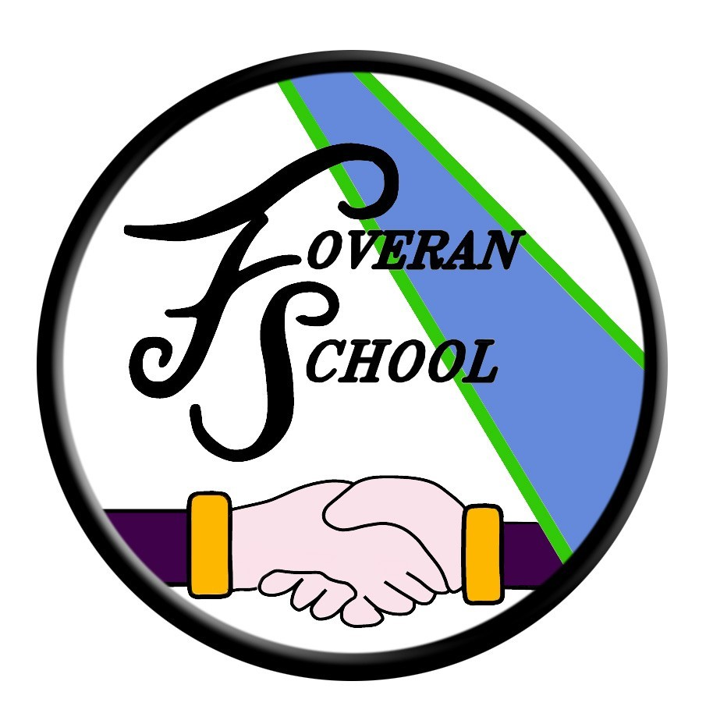

Photograph/video Policy

Photograph/Video Policy
This policy applies to sporting events, parents’ evenings, plays, assemblies, school trips and any other school event or gathering, whether on school premises or beyond.

We appreciate that families will treasure photographic/video memories, and the general rule is that parents and carers may take photos and videos of the children in their care, for personal use only. There may be rare exceptions to this, and we will let you know in advance of particular events where no filming etc. is possible. Thank you in advance for your understanding.

Live streaming, whether public or private, cannot be permitted and we request that you do not use any streaming platforms or ‘live’ features (e.g. Facebook Live) to stream events/circumstances as they occur. You may be asked to leave the premises or event if this takes place.

When you capture footage or still images of your children, there is a strong possibility that other children will also be visible or audible. For this reason, no such content should be shared publicly. You will have seen other parents share videos of school plays on social media, but this does not make it advisable or acceptable.

There are several important reasons for this:
- Some children are deemed at risk by local authority safeguarding and child protection authorities; their image must never be put online for their own protection. You are very unlikely to know who these children are. Others may have complex family backgrounds which mean that sharing their image could have unforeseen consequence. There is the real possibility you could endanger a child by sharing their image in an identifiable context (e.g. where the school is easy to identify and locate).
- Express consent is needed from parents to comply with data protection legislation, which is being enhanced under GDPR and the new Data Protection Bill. Sharing could otherwise potentially incur fines for contravention of data protection rules.
- Some families may object for religious or cultural reasons, or simply for reasons of personal privacy.
- Sharing images of children in school uniform helps identify them so should not be done unless avoidable.
- We encourage young people at our school to think about their online reputation and digital footprint: online photos and videos do not simply disappear when we delete them from our accounts. Help us be good adult role models by not oversharing (or providing embarrassment in later life).

Where possible, we will take appropriate staged group shots of pupils whose parents/carers have given appropriate photographic permissions and make these available to you. Equally, and again wherever possible, we will ensure there is time for parents to take photographs of their own children for example by approaching the stage after a performance. The same provisos apply here as stated above.

The Head Teacher at Foveran School welcomes feedback on this document.

Contact:

Foveran School
Main Road
Foveran
Ellon
Aberdeenshire
AB41 6AZ

Tel: 01358 281115
E mail: Jamie.ferguson@aberdeenshire.gov.uk

