Foveran School
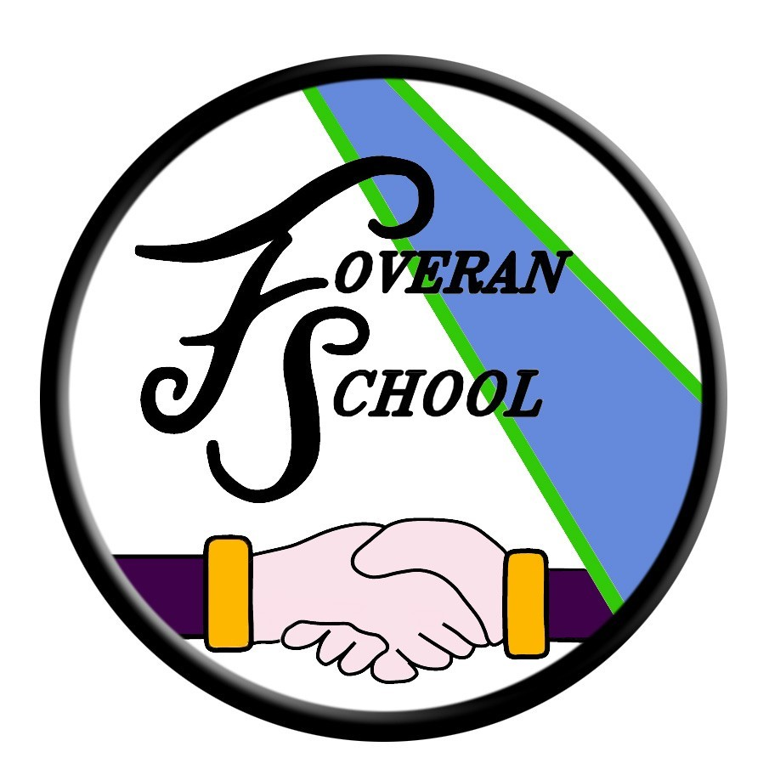

Religious and moral education Policy

Religious and Moral Education Policy
Rationale
Scotland is a nation whose people hold a wide range of beliefs from the many branches of the Christian faith represented throughout the land to the world’s other major religions and to beliefs which lie outwith religious traditions. Such diversity enriches the Scottish nation and serves as an inspiring and thought-provoking background for our children and young people to develop their own beliefs and values.
Religious and moral education enables children and young people to explore the world’s major religions and views which are independent of religious belief and to consider the challenges posed by these beliefs and values. It supports them in developing and reflecting upon their values and their capacity for moral judgement. Through developing awareness and appreciation of the value of each individual in a diverse society, religious and moral education engenders responsible attitudes to other people. This awareness and appreciation will assist in counteracting prejudice and intolerance as children and young people consider issues such as sectarianism and discrimination more broadly.
Children and young people must become aware that beliefs and values are fundamental to families and to the fabric of society in communities, local and global. There is an intrinsic value in learning about religion as well as learning from religion, as children and young people develop their understanding of diversity in our society and their own roles in it. The skills of reflection and critical thinking and an enhanced understanding of the beliefs and values of others are all crucial in assisting in this process.

Learning through religious and moral education enables children and young people to:
• recognise religion as an important expression of human experience
• learn about and from the beliefs, values, practices and traditions of Christianity and the world religions selected for study, other traditions, and viewpoints independent of religious belief
• explore and develop knowledge and understanding of religions, recognising the place of Christianity in the Scottish context
• investigate and understand the responses which religious and non-religious views can offer to questions about the nature and meaning of life
• recognise and understand religious diversity and the importance of religion in society
• develop respect for others and an understanding of beliefs and practices which are different from their own
• explore and establish values such as wisdom, justice, compassion and integrity and engage in the development of and reflection upon their own moral values
• develop their beliefs, attitudes, values and practices through reflection, discovery and critical evaluation
• develop the skills of reflection, discernment, critical thinking and deciding how to act when making moral decisions
• make a positive difference to the world by putting their beliefs and values into action
• establish a firm foundation for lifelong learning, further learning and adult life.

The Development of Pupils’ Values
We implement the Council policy for Equal Opportunities and ensure that all pupils have access to the full range of educational experiences available within the resources of the school. We are firmly committed to the elimination of any form of discrimination on the grounds of age, race, religion, gender, sexuality or disability.

Religious and Moral Education
Throughout the school there are opportunities for pupils to learn about aspects of Christianity, other world faiths and to reflect upon their own moral standpoint in relation to world issues. During weekly whole-school assemblies, we encourage awareness of matters of a cultural, social and moral nature.
We aim to develop in our pupils an ethos of tolerance, understanding and respect for the beliefs and customs of others. The school is committed to supporting the development of its pupils as whole people and as a result, wish to encourage their development in moral, social and cultural terms.
The School Chaplain ‘Rev. Ricky Reid’ and a local Christian ‘James Strachan’ visits the school on a regular basis to tell bible stories and teach about morals/values.
Parents wishing to exercise their right to withdraw their child from Religious and Moral Education should contact the head teacher so that acceptable alternative arrangements can be made.

The Head Teacher at Foveran School welcomes feedback on this document.

Contact:

Foveran School
Main Road
Foveran
Ellon
Aberdeenshire
AB41 6AZ

Tel: 01358 281115
E mail: Jamie.ferguson@aberdeenshire.gov.uk

