Foveran School

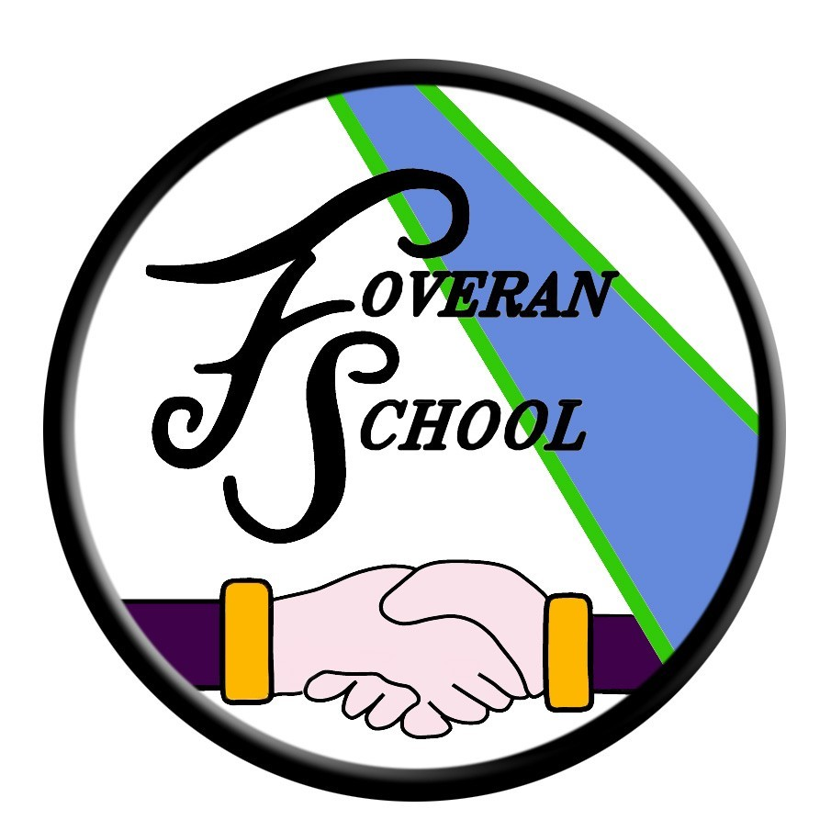

Transitions Policy

Transitions Policy
We understand that transitions, especially at P1 and S1 stages, can be anxious times for parents and pupils. At Foveran School we have arrangements in place to support transitions and these are outlined below.

Deferrals to P1
Where parents have concerns regarding their child’s entry to P1, they should discuss this with their nursery team in the first instance who will be able to offer support and guidance.

Transfer to Primary 1
In order to support and ease transition into P1, we arrange an induction event for you and a set of visits for your child. These events are planned to allow you and your child to become familiar with the school building, to meet staff, to meet with the other children including your child’s buddy and to find out about life in school and what you can do to support your child’s transition into P1. The induction process starts in your child’s pre-school year, with P1 staff arranging to visit your child in their pre-school setting wherever possible in order to begin to get to know your child.

Induction meetings are arranged for parents around May/June in order to share information about starting school and how you can help your child at home. This is also an opportunity for parents to meet their child’s teacher and to ask any questions or share any information.

At these induction meetings, parents are issued with a range of materials designed to support children’s learning at home and parents are asked to complete a range of forms to gather information about e.g. your child’s medical needs, contact addresses, special needs etc.

Our prospective P1s also have the opportunity to come into class for a series of induction sessions around May/June. This allows the children to begin to get to know their classmates and their teacher as well as familiarising themselves with the school buildings and classroom routines. Parents are also invited to join their P1 children for a school lunch.

Information communicating details of P1 induction arrangements along with dates will be communicated directly to prospective P1 parents around April.

Primary to Secondary Transition Process
The move from primary to secondary school for most pupils is a very easy one but it can be an anxious time for some pupils and their parents/carers. To ease this, we work closely with our class teachers, support staff, pupils and parents/carers to minimise concerns. During the transition process, detailed information is gathered on each pupil and shared with staff in the Academy to ensure effective personal and learning support strategies are in place.

To facilitate individual needs, an extended transition programme is available for pupils with significant additional support needs. Health professionals, Educational Psychologists, Social Work, CSN Pupil Support worker, Community Learning workers, other professionals and voluntary organisations may be involved in ensuring a smooth transition from primary schools to the Academy.

Ellon Academy staff will visit all cluster primary schools to get to know the children, deal with worries and concerns, gather and share information and support pupils during the transition process to the Academy.

Where parents opt to send their child to any other secondary school, (following placing requests) Foveran School will support any alternative transition arrangements wherever possible.

Transitions between Stages
For some children, the thought of moving onto their next class/teacher can also be an anxious time. Again, we have structures in place to support these transitions. Teachers share planning and work together on school improvement projects helping to ensure a commonality of expectations and approaches. Time is arranged for teachers to hand over information regarding the learning needs of the pupils transferring from class to class. Around June of each year “step up” time is also arranged where pupils can meet their next teacher and their classmates.
If you have any particular concerns regarding transitions, please make an appointment to see the head teacher.
Visit Parentzone for more information about transitions:
https://education.gov.scot/parentzone/my-child/transitions

The Head Teacher at Foveran School welcomes feedback on this document.

Contact:

Foveran School
Main Road
Foveran
Ellon
Aberdeenshire
AB41 6AZ

Tel: 01358 281115
E mail: Jamie.ferguson@aberdeenshire.gov.uk

