Foveran School

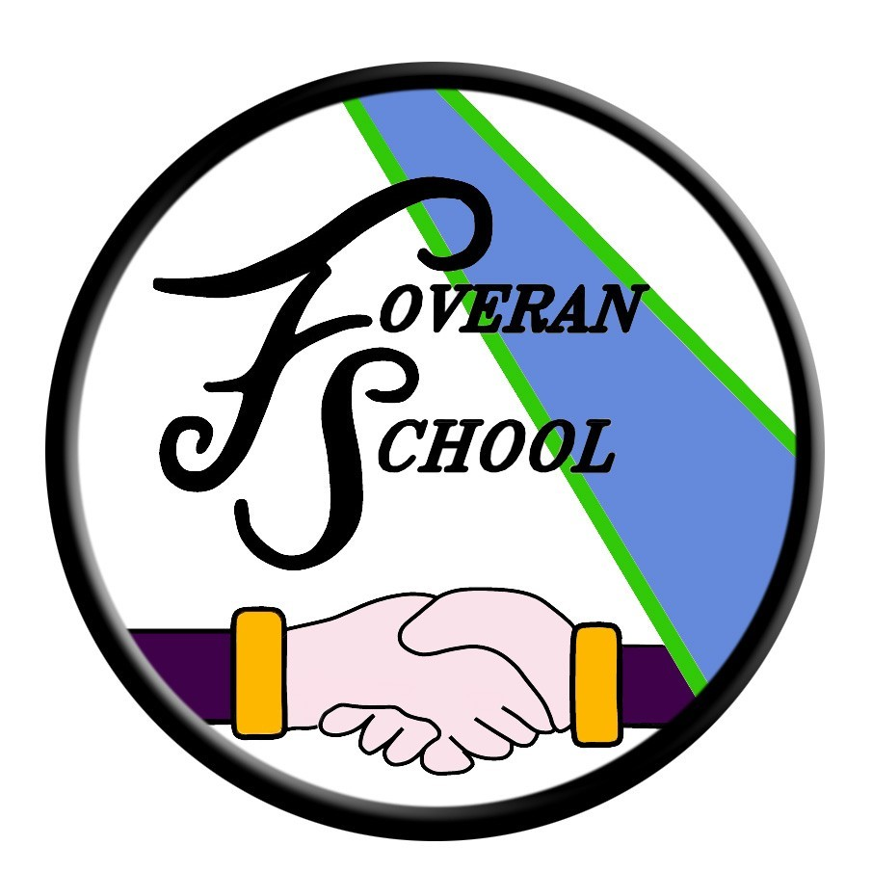

Uniform Policy

Uniform Policy

We encourage all pupils to wear school uniform. This helps to instil a sense of pride and team spirit within our school. Sweat shirt orders are processed in the autumn and spring terms. A limited stock of sweatshirts is also kept in school. We can also provide ‘nearly new/recycled’ sweatshirts for parents who would wish to make use of these.
School uniform consists of - school sweatshirt with school logo, white polo shirt, dark school skirt or trousers, dark school shoes & laces (children should not wear high heeled shoes as these cause safety concerns). We appreciate your cooperation in support of this. Make-up is not permitted at our school unless prior permission is sought.
Please consider the changeable nature of weather conditions and provide your child with appropriate outerwear and footwear to suit.
PE Kit consists of sports t-shirt, sport leggings/shorts/cycling shorts, socks, sport shoes (preferably with Velcro or elastic fastening for younger pupils) all kept in a gym bag.
With regard to safety, the wearing of jewellery (which we actively discourage) is not permitted during PE lessons. If your child has pierced ears, please ensure they can remove and replace earrings by themselves. Any child wearing earrings that cannot do this will be asked to put surgical tape over them for PE lessons. (Parents should provide a named roll of surgical tape for this purpose.) Shoe string strap tops are also discouraged for safety reasons as they can catch on gym apparatus.
All clothing brought to school should be named or marked in some way, as it is difficult for children to distinguish their own clothing from that of others.

Clothing Grants
Some families may be entitled to a school clothing grant of £50 per year. More information about this can be found at:
http://www.aberdeenshire.gov.uk/schools/parents-carers/assistance/school-clothing-grants/

The Head Teacher at Foveran School welcomes feedback on this document.

Contact:

Foveran School
Main Road
Foveran
Ellon
Aberdeenshire
AB41 6AZ

Tel: 01358 281115
E mail: Jamie.ferguson@aberdeenshire.gov.uk

