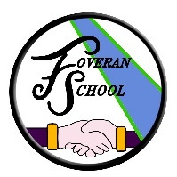
School Vision, Values & Aims

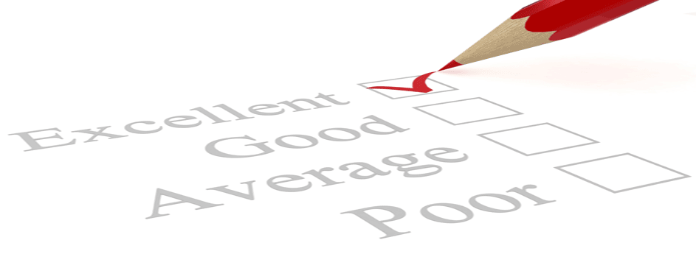
Successful, Independent, Confident and Responsible

Foveran School aims to provide an excellent education for our pupils, a safe and nurturing environment and an ethos that celebrates confident individuals, responsible citizens, effective contributors and successful learners.
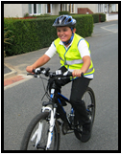

Improvements in performance
• Raised attainment over time
• High quality of learners’ achievement
• An effective school improvement plan

Learners’ experiences
• Motivated and actively involved learners
- Lessons that are interesting, contextualised and memorable
- Pupils taking ownership of learning and learning how to learn

The Curriculum
• Curricular policies that have rationale and a coherent design
• Continued development of the curriculum
• Programmes and courses that ensure a broad education
• Improved transitions to prepare our pupils for meeting the emotional, physical and social demands in changes at critical periods
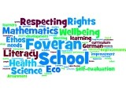
Meeting learning needs
• Tasks, activities and resources that challenge and support all of our pupils
• Identification of learning needs specific to our pupils
• Ensure optimisation of roles of teacher’s skills and knowledge
• Continued monitoring to guarantee that we meet and implement the requirements of legislation

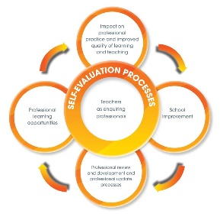
Improvements through self-evaluation
- Commitment to identify strengths and areas for development
- Continually compare and contrast our standards and achievements against national standards
- Specific professional development training needs identified particular to the school
- Acknowledging success and addressing stakeholder concerns regularly

