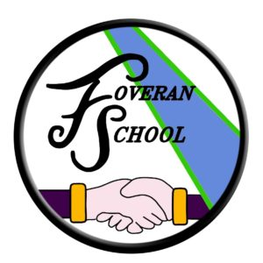
Foveran Primary - Parent Council Meeting
Tuesday 10th May 2022
(via Teams)

Present: Jamie Ferguson (Head Teacher – JF), Sarah Williams (Chairperson - SW),
Lynn Bowman (Vice Chairperson - LB), Jennifer McLoughlin (Secretary - JM),
Mike Cleverdon (MC), Eilidh MacKechnie (EM)

Apologies: Rachael McClintock (Treasurer - RM), Lisa Proud (LP), James Carter (JC)

Item | Description | Action
1 | Introductions and Apologies
 | As above
2 | Minutes of Previous Meeting
2.1 | Previous minutes agreed
3 | School Update from Head Teacher
3.1  3.2  3.3  3.4 | School Updates  Survey responses - thank you to everyone for filing out the surveys, further questions will go out relating to the provision of indoor shoes.  Congratulations to Mrs du Plessis who is expecting a third child in September.  Student Heather Smith, next week is her final week.  P1 Transitions - process is underway. SW added that most of the new P1 parents have now been added to the Foreran Primary WhatsApp group.  Parking is still an issue outside the school with some complaints received from local residents. Please park on Blairythan Terrace or Westfield Drive where possible.  Reporting - school reports will be issued on Friday with Parents evening 24th/25th May.  Standards and Quality report/Improvement Planning  SQUIP dates change this year. Survey may go out at the next Community Café to help with improvement plan.  Upcoming Events  Community Café – Wednesday 1st June – Platinum Jubilee Theme  Richard Michaels (Jazz musician) – Monday 13th June for mini recital  Upcoming trip to Foveran Church (Date TBC)  Trip to Ellon Fire station (Date TBC)  Visit from Police (Date TBC)  End of term Talent Show (in classroom) – Wednesday 29th June – Judges will be required.  End of term celebration Friday 1st July  Funding  Hill of Fiddes applications – totalling £7550.99 have been approved for new library and books.
4 | Treasurer Update
4.1 | Bank Balance is healthy, but fundraising is required.
5 | Fundraising
5.1  5.2 | RM suggested a Beetle Drive at the hall with a raffle, bottle stall etc  An end of term party at the hall for the children was also suggested. Could be combined with a BBQ in the park.
6 | Upcoming Events
Community Café – Wednesday 1st June – Platinum Jubilee Theme
End of term celebration Friday 1st July
7 | AOB
7.1  7.2 | Volunteers to help with school trips may require to have PVG. PC to look into this.  Books to be purchased as end of term gifts for the children. Teachers will put together a list of books, PC to fund and make individual labels to go inside. | SR/LB  JF/PC
8 | Date of Next Meeting
 | Tuesday 14th June – 7.45pm

